90

Tips for Conducting Good Interviews
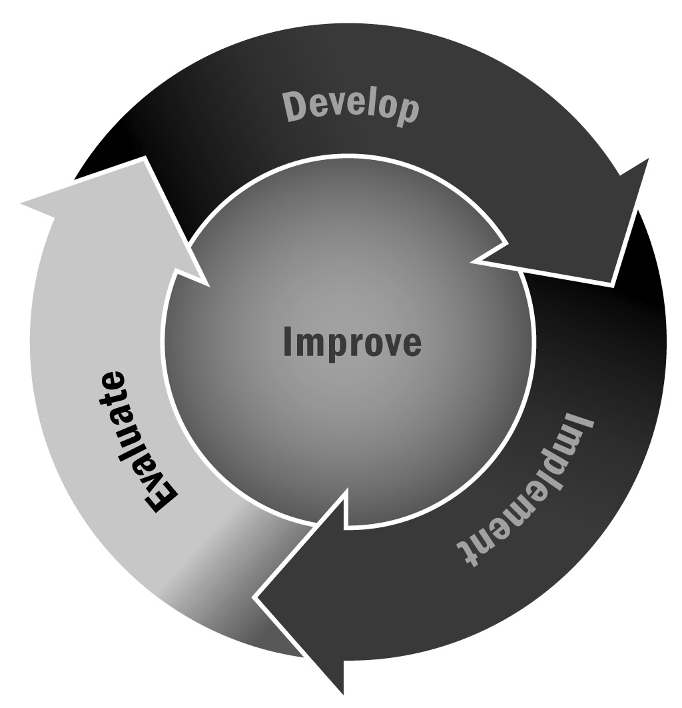
In Chapter 5, you learned that no matter how well you plan your activities, your evaluation questions, and your evaluation plan, it will all be for naught if you don’t have a useful way to collect the data you will need to answer your evaluation questions. One way to collect data is through interviews.
Directions: Use the following tips when conducting interviews as part of your data collection efforts.

- Review the interview questions in advance of conducting the interview so that you are familiar with all of the questions. Practice asking the questions.
- Bring a hard copy of the interview questions.
- Notes and tape recording should be used for all interviews. If interviewees don't want to be taped,
rely on notes.
- Bring a notepad and pen to take notes in case you have computer problems.
- For recording, say the name, position, school, and date of person being interviewed before beginning interview.
- Maintain confidentiality (do not reveal what others have said in interviews; keep notes safe).
- Turn off cell phones.
- Clearly state the purpose of the interview and how the information from the interview will be used.
- Stay on schedule, and prioritize questions if you will not have enough time to ask all of them.
- Ask to conduct the interview in a private meeting space.
- When asking the questions, avoid using jargon, and rephrase questions if needed to enhance the interviewee’s understanding.
- Ask for clarification if the interviewee is using terms or acronyms that you are not familiar with.
- Ask follow-up questions if needed.
- Review and clean your notes as soon as possible following the interview.

